Register and Login

Use case:
List Users and authorize

Search friends, req

List and View all Friends Req and Res


Create disaster Tweet
User
View all your disaster tweets and comments
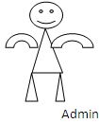
Find disaster Tweet relationship between different tweets
User
View all other friends’ disaster tweets and make your comment

Find number disaster tweets words used

View all your friends and their profile details

